MORNING WORSHIP SERVICE
Aug 21, 2016

Opening “This Is the Day” 359

Opening Prayer/Announcements
K s b c

Keeping His Word through Sunday School, Bible Study and Church Attendance/Worship

Sunday School Bible Studies for August:

August 7th Manage Money Diligently Proverbs 31:13-21
August 14th Invest Money Wisely Ecclesiastes 11:1-6
August 21st Give Money Generously Proverbs 1:23-29
August 28th Love Gets Involved Luke 10:25-37

9:45 a.m. each Sunday – A place for everyone

Worship Hymns “Praise Him! Praise Him!” 227
“Without Him” 300
“When the Roll Is Called Up Yonder” 516
“We Have Come into His House” 361
“Surely the Presence Of the Lord”

Offering/Offertory

Special Music

Message Bro. David Atwood
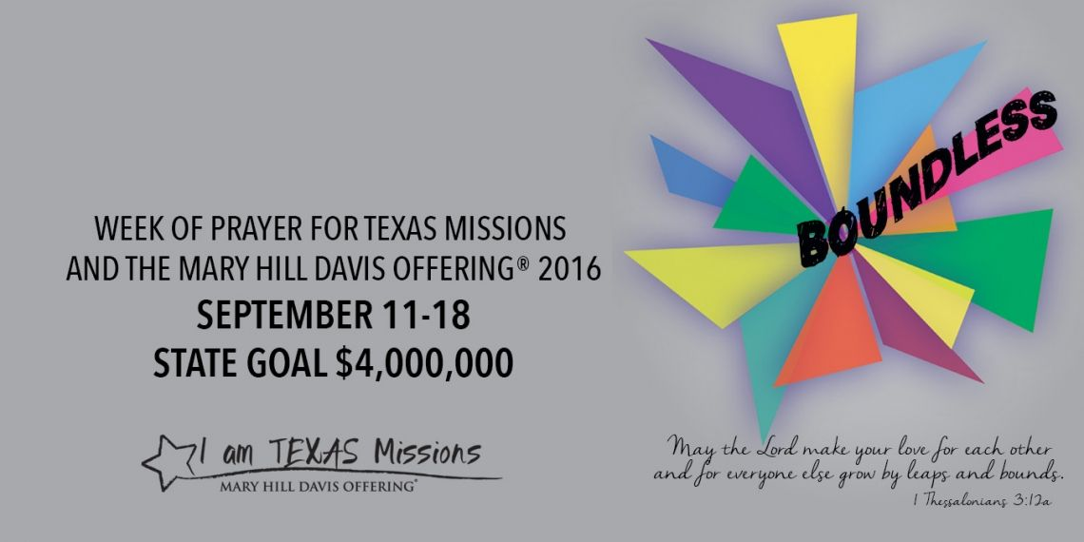

Invitation “Just As I Am” 307

Closing Prayer

Evening Service @ 6:00pm

NURSERY – available for children age 0 to Kindergarten
Jana Moore

Hostesses for August Ushers for August
Diann Stutes, Evelyn Robinson, Joe Daniel, Mickey Stanford,
Hugo & Carolyne Breithaupt David Condron, Hugo Breithaupt

Immediate Need Prayer List
Prayer & Request Information

(Please complete name & address information on reverse side)

❑ I would like to speak with the Pastor.

❑ I would like more information on this church.

❑ I have Prayer Requests or Needs

Date:

Permission to Publicize:
Church Bulletin  Yes  No
Email Prayer Chain  Yes  No

Prayer Request:

Prayer For
Name
Address
Phone

Given By
Name
Address
Phone
Please Contact By

❑ Card  Phone  Visit

Comments

Pray for unsaid fears and concerns

Pray for Helen Emery as she recovers in rehab and prepares to move to Livingston

